

**Faculty of engineering - Shoubra**

**Benha University**

**Research Article / Research Project / Literature Review**

in fulfillment of the requirements of

|  |  |
| --- | --- |
| **Department** | **Electrical Engineering** |
| **Division** | **Communications** |
| **Academic Year** | **First** |
| **Course name** | **Computer Application 1** |
| **Course code** | **ECE 124C** |

**Title: -**

**“**Research Project: Web Site using HTML, CSS, and JS”

By:

|  |  |  |  |
| --- | --- | --- | --- |
|  | Name | Edu mail | B.N |
| 1 | أحمد مجدي عبدالرحمن | Ahmed180107@feng.bu.edu.eg | Section 1 |

**Approved by:**

|  |  |
| --- | --- |
| Examiners committee | Signature |
|  |  |
|  |  |
|  |  |
|  |  |
|  |  |

**GitHub link:** <https://github.com/A7med-star/library-project>

**GitHub pages:** <https://a7med-star.github.io/library-project/>.

**Introduction**

**A library is a curated gathering of information sources and similar resources, selected by experts and made available for reference or borrowing to a defined community, often in a quiet environment conducive to study. It provides physical or digital material access, and can be a physical location, a virtual room, or both.**

**The collection of a library may include books, newspapers, newspapers, manuscripts, films, maps, prints, documents, microforms, CDs, cassettes, videotapes, DVDs, Blu-ray disks, e-books, audiobooks, databases, etc. The collections vary widely up to millions of items in size. In Latin and Greek, Bibliotheca and Bibliothēkē embody the idea of a bookcase.**

**The first libraries were collections of the earliest type of writing — the clay tablets found in cuneiform script in Sumer, some dating back to 2600 BC. In the 5th century BC private or personal libraries, composed of written books, appeared in classical Greece. Throughout the 6th century, the great libraries of the Mediterranean world remained those of Constantinople and Alexandria at the very close of the Classical period. Even during this time the Timbuktu libraries were founded and attracted scholars from all over the world.**

**A library is arranged for use by a public entity, agency, corporation, or private person, and is maintained. Public and institutional collections and services may be intended for use by individuals who choose not to — or cannot afford to — purchase an extensive collection themselves, who need material that no individual can reasonably be expected to have, or who require professional support in their research.**

**Literature Review**

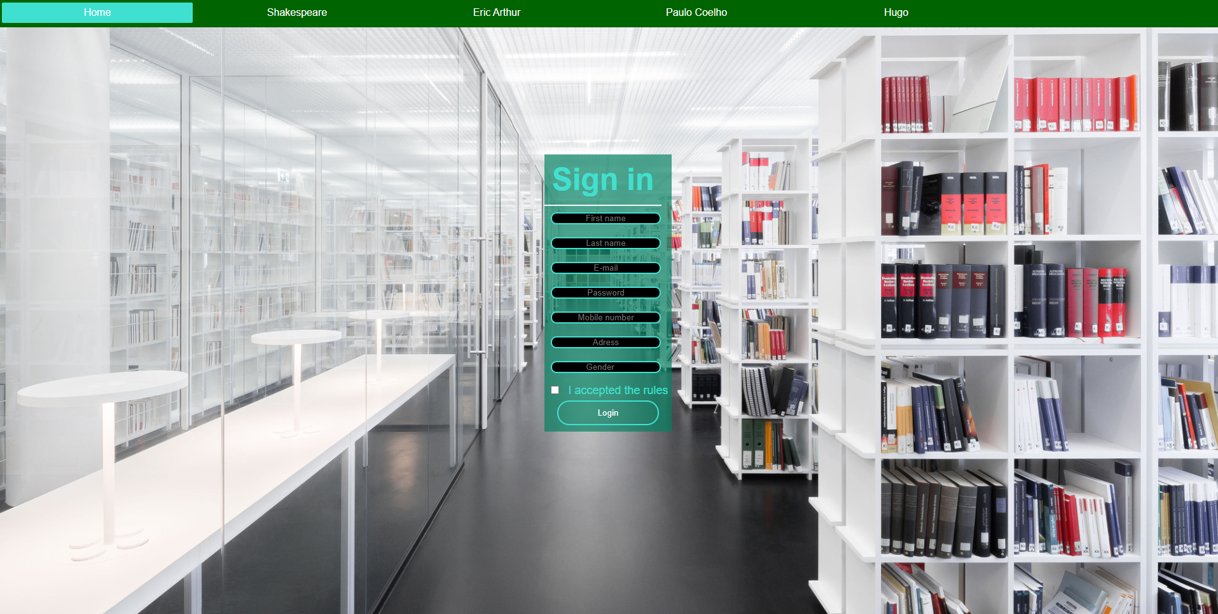**Form**

**This page talked about the form of a visitor with background worthy of the topic.**

**as we noticed that the navigation bar, it is built by <ul> and tag <a> and some styles in CSS.**

**The form is built by the tag <form> and <input> and it is in this place by (margin: 200px auto;).**

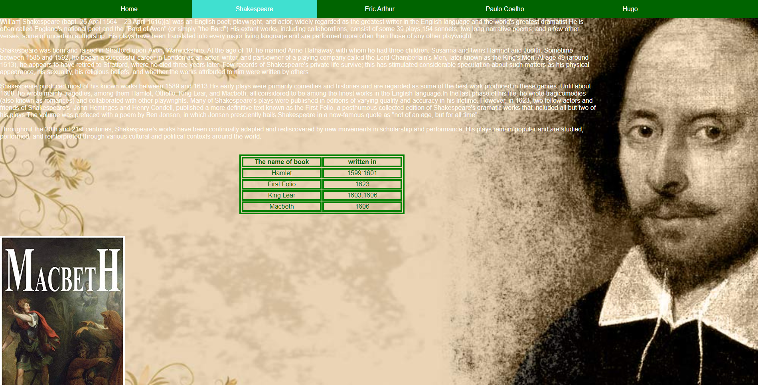 **Shakespeare**

**This page talked about the big writer Shakespeare and his great works by some paragraphs with tag <div> with white color in font color.**

**Also, we put this table in middle by (margin: Auto) with green color and (text-align: center) and (border: 2px solid).**

**Finally, we put the photo by tag <img>.**

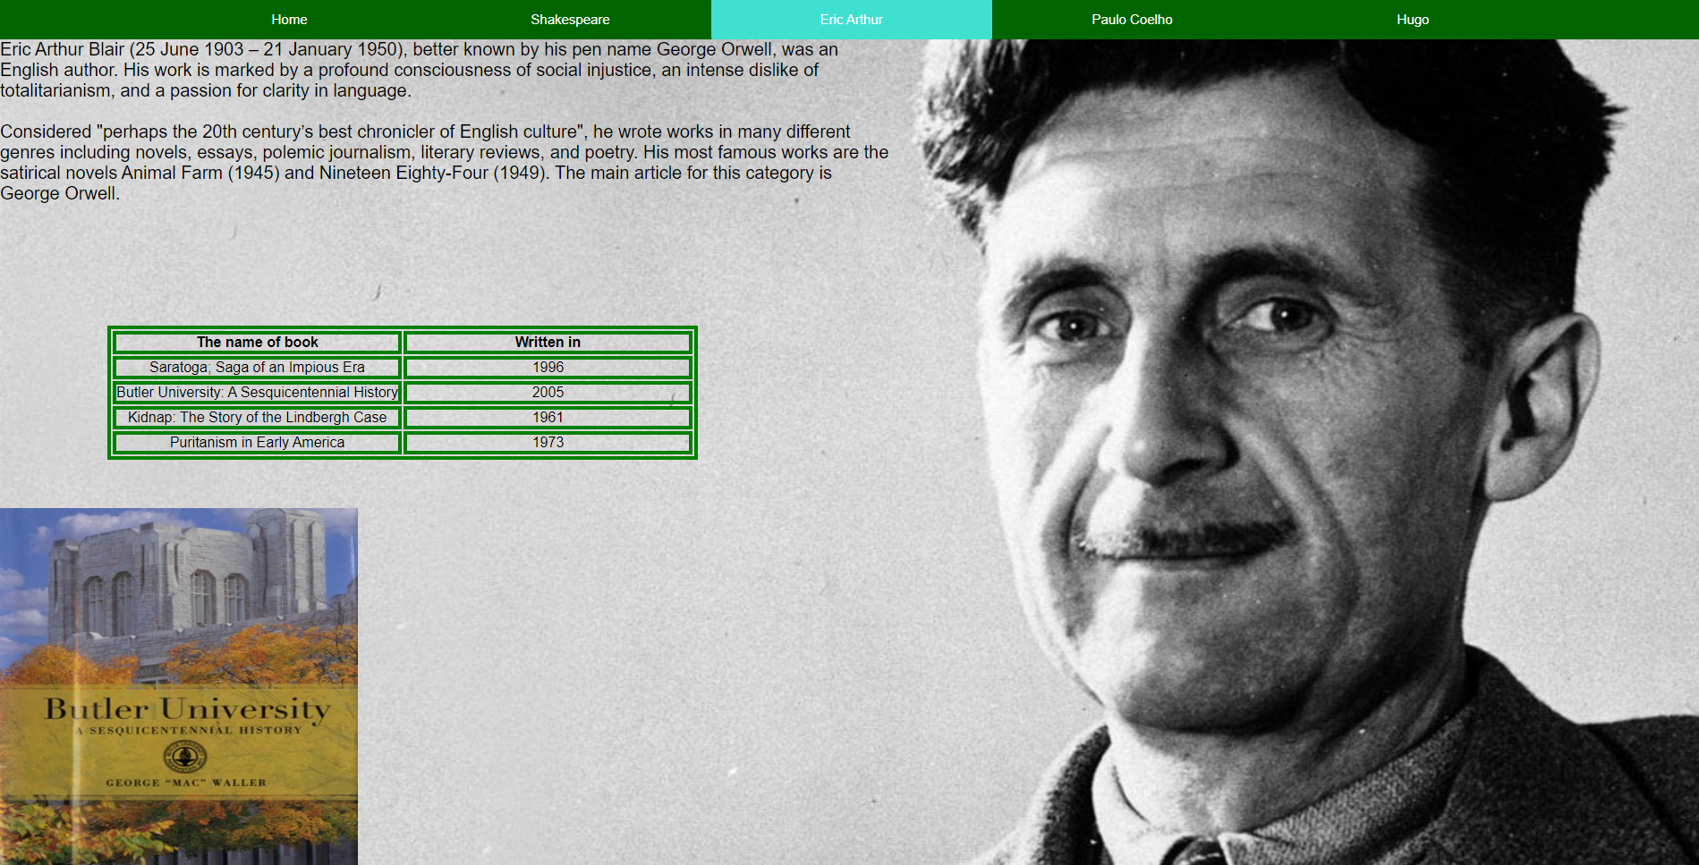 **Eric Arthur**

**This page talked about the great Eric Arthur and his great works by some paragraphs with tag <div> with black color in font color.**

**Then we put this table in middle by (margin: 100px 120px;) with green color and (text-align: center) and (border: 2px solid).**

**Finally, we put the photo by tag <img>.**

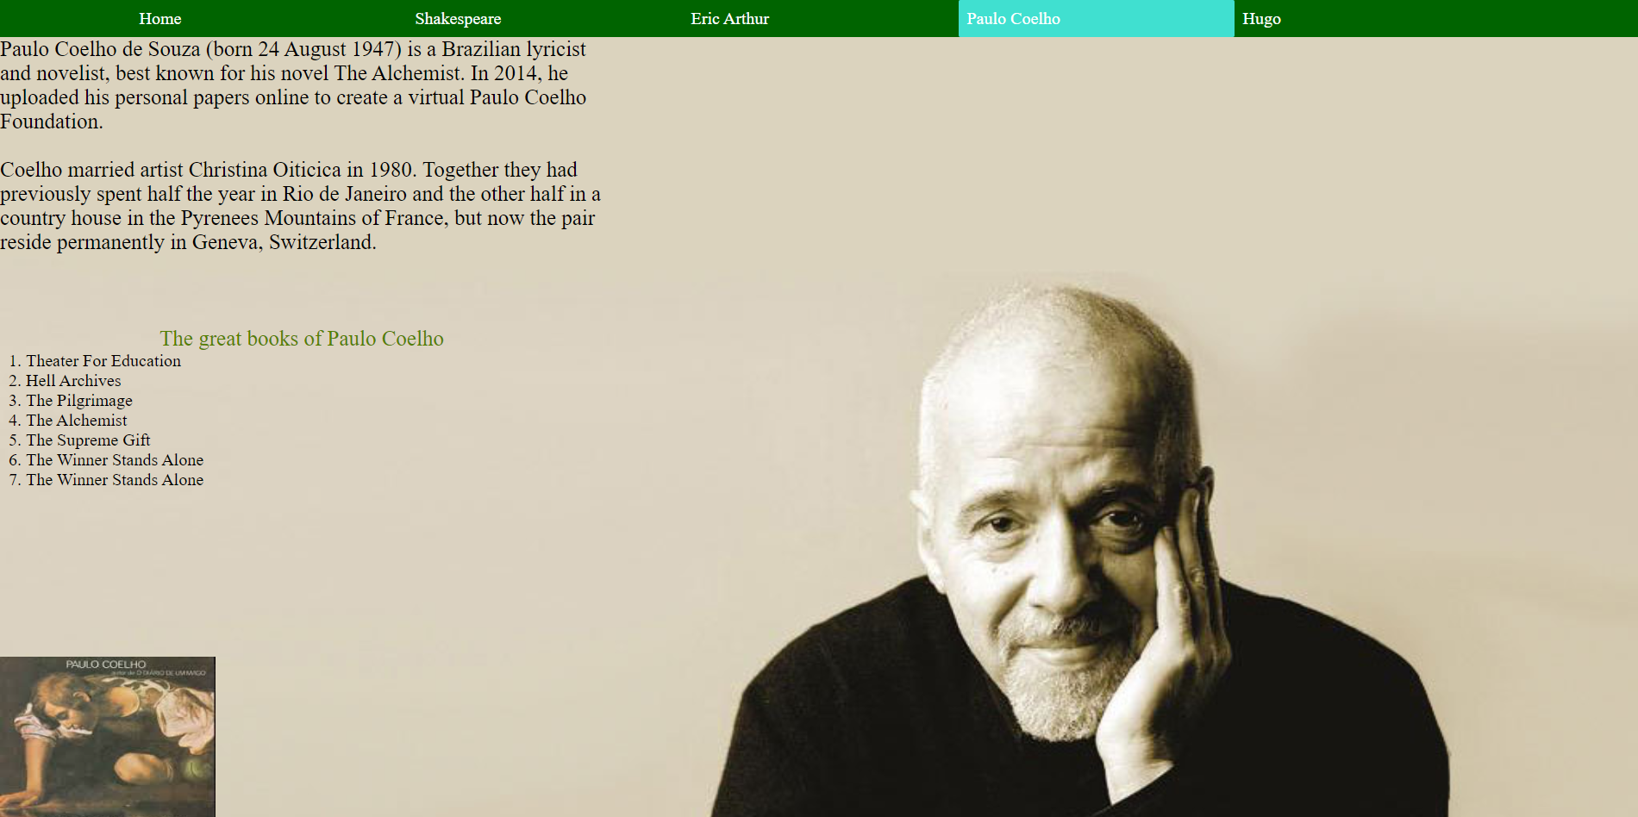**Paulo Coelho**

**This page talked about one of the great writers in history he is Paulo Coelho by some paragraphs with tag <div> with black color in font color.**

**Then we put a list of great works of him by the tag <ul> and**

**(style-list: decimal) with big caption by tag <caption> and color green.**

**Finally, we put image by tag <img>.**

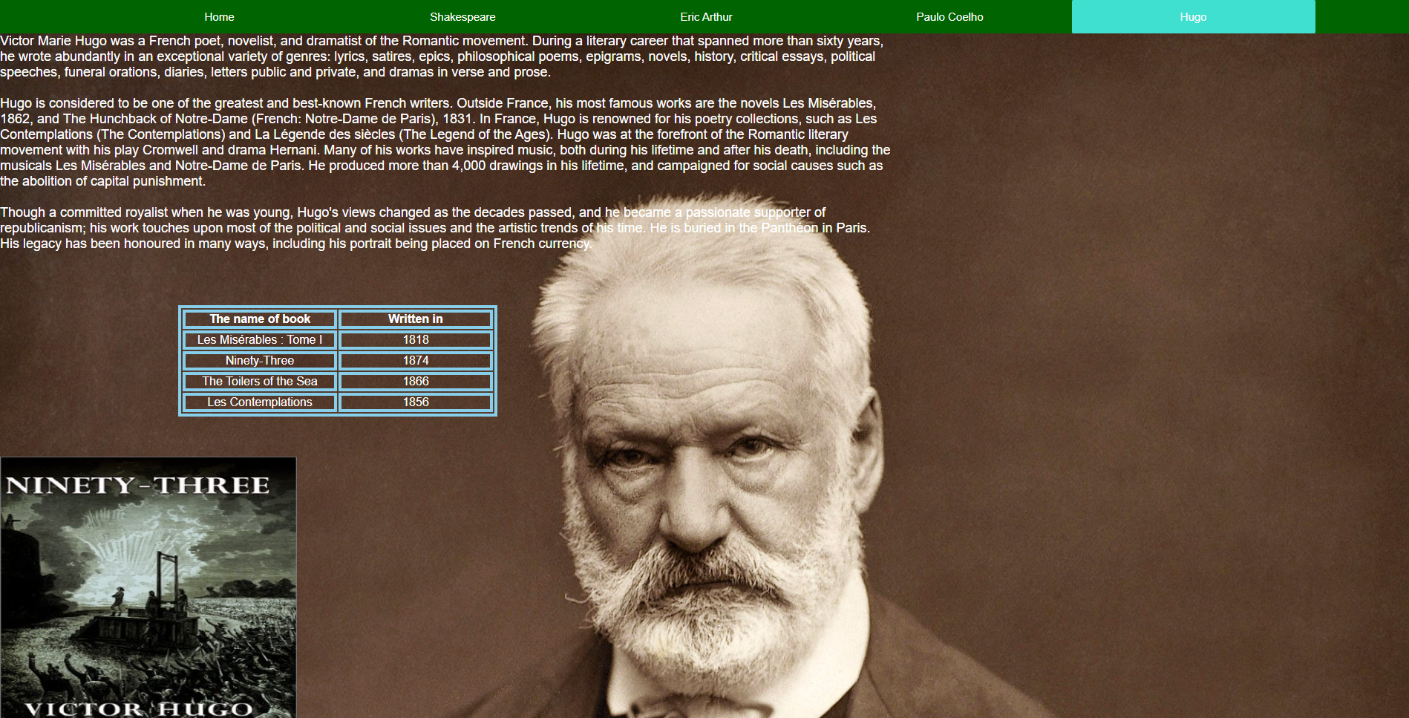**Hugo**

**This page talked about one of the great writers in history he is Hugo by some paragraphs with tag <div> with black color in font color.**

**Then we put this table in this place by (margin-left: 240px;) with green color and (text-align: center) and (border: 2px solid).**

**Finally, we put image by tag <img>.**